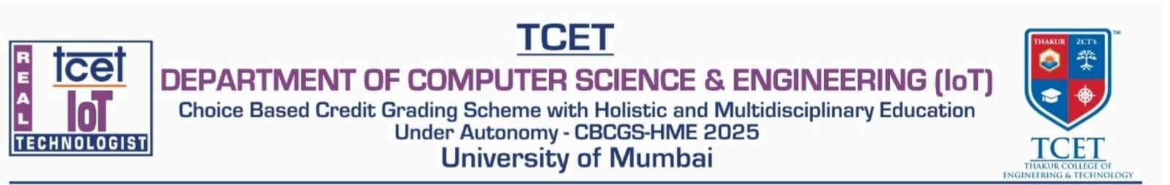
A.Y. 2026-2027
NAME – Himanshu Basant Naik Subject - Fundamentals of Internet of Things
BRANCH – CSE(IoT) SEMESTER – III
ROLL NO - 01 Faculty – Mr. Sunil Khatri / Ms. Ekta Desai

PRACTICAL 1
Aim | Study of Arduino, Various Microcontrollers Along with Their Respective Boards, Configurations, Specifications, Advantages, Challenges, and Application Areas
Objectives | - To study Arduino and various microcontroller families, their development boards, configurations, specifications, advantages, and limitations.  - To compare microcontroller and single-board-computer platforms based on processor, memory, communication interfaces, power consumption, and their suitability for IoT and embedded system applications.  - To gain hands-on experience with the IDEs, toolchains, and programming of different development boards.
Hardware / Software Requirement | Hardware Requirements  - Desktop computer or laptop  - Arduino Uno development board  Software Requirements  - Arduino IDE - to write, compile, and upload programs to Arduino Board
Theory | 1. Introduction to Embedded Systems  An embedded system is a combination of computer hardware and software designed to perform a specific, dedicated function within a larger mechanical or electronic system. Unlike general-purpose computers, embedded systems are optimised for a narrow set of tasks, real-time response, low power consumption, and low cost. They form the computing core of everyday products such as washing machines, automobiles, medical instruments, and Internet of Things (IoT) devices.  2. Microcontrollers and Development Boards  A microcontroller (MCU) is a compact integrated circuit that combines a processor core, memory (Flash, SRAM, and sometimes EEPROM), and programmable input/output peripherals on a single chip. It is designed to execute a dedicated control program rather than run a general-purpose operating system. A development board is a printed circuit board that exposes a microcontroller's (or, in the case of single-board computers, a microprocessor's) pins through headers, adds a USB-to-serial interface, voltage regulation, and supporting circuitry, so that the chip can be programmed and prototyped easily without designing custom hardware.  3. What is Arduino  Arduino is an open-source electronics platform consisting of programmable microcontroller boards and the Arduino IDE, a cross-platform application written in C and C++ that allows users to write, compile, and upload sketches to the board. Arduino was created to make embedded programming accessible to students, hobbyists, and engineers without requiring deep hardware-design expertise. Because of its low cost, simple C/C++-based programming model, and very large community, Arduino is widely used in robotics, home automation, IoT, and educational projects.  4. Importance in the Internet of Things (IoT)  Microcontroller and single-board-computer platforms are the building blocks of IoT systems: they acquire data from sensors, perform local processing, and communicate over wired or wireless links to a gateway or cloud service. The choice between a low-power microcontroller (such as an Arduino or ESP32) and a more powerful single-board computer (such as a Raspberry Pi) is driven by trade-offs between processing capability, power budget, connectivity, and cost.  5. Working Principle and Architecture Overview  Every microcontroller-based system follows a common input-process-output cycle: sensors or switches provide input, the CPU executes the stored program (fetched from Flash memory) using RAM for temporary variables, and the result drives output devices such as LEDs, motors, displays, or wireless radios. Two broad processor design philosophies are used across the boards studied here: the Harvard-style AVR core in classic Arduino boards, and 32-bit RISC architectures (ARM Cortex-M/A, Xtensa, and RISC-V) used in the ESP, Raspberry Pi, BeagleBone, Aries V, and STM32 families.  6. GPIO - General Purpose Input/Output  GPIO pins are digital pins that can be individually configured by software as either input or output. As inputs they read the logic state of switches or digital sensors; as outputs they can drive LEDs, relays, or logic-level signals to other circuits. Many GPIO pins are additionally multiplexed with special functions - PWM generation, ADC/DAC, or a serial communication peripheral - and the number, voltage level, and current-driving capacity of GPIO pins varies significantly across the board families compared in this experiment.  7. Communication Protocols  - UART (Universal Asynchronous Receiver/Transmitter): a simple two-wire (TX/RX) serial protocol used for point-to-point communication, commonly used for the Serial Monitor and for GPS/Bluetooth modules.  - SPI (Serial Peripheral Interface): a high-speed, full-duplex, master-slave bus using MOSI, MISO, SCK, and chip-select lines; used for displays, SD cards, and sensors that need fast data transfer.  - I²C (Inter-Integrated Circuit): a two-wire (SDA/SCL) multi-master, multi-slave bus that allows several devices to share the same pair of lines using unique addresses; common for sensors and RTC modules.  - CAN (Controller Area Network): a robust, differential, multi-master bus designed for noisy environments; supported by STM32 and BeagleBone-class boards and widely used in automotive and industrial control.  - USB (Universal Serial Bus): used both for powering boards and, on most boards, for programming and virtual-serial communication with a host computer.  8. Memory Types  - Flash Memory: non-volatile memory that stores the compiled program (firmware); retains data without power.  - SRAM: fast, volatile memory used to hold variables and the call stack during program execution; contents are lost on power-off.  - EEPROM: small, non-volatile memory (present mainly on AVR-based Arduino boards) used to store configuration data that must survive a power cycle.  9. Processor Architecture, Clock Speed, and Operating Voltage  Processor architecture (8-bit AVR, 32-bit ARM Cortex-M/A, Xtensa, or RISC-V) determines instruction throughput and the width of data that can be processed per cycle. Clock speed sets how many instruction cycles are executed per second, directly affecting processing capability and power draw. Operating voltage (commonly 3.3 V or 5 V for microcontrollers, and 5 V supply for single-board computers) must be matched when interfacing sensors and modules across boards to avoid damaging I/O pins.  10. Wireless Capability and Programming IDEs  Wireless connectivity (Wi-Fi, Bluetooth/BLE, or cellular) is either built into the SoC (as in the ESP32 and Raspberry Pi) or added via an external module, and is a key differentiator for IoT applications. Every board family is supported by at least one dedicated IDE or toolchain - the Arduino IDE, STM32CubeIDE, Raspberry Pi OS with VS Code/Thonny, or the VEGA SDK/Arduino core for Aries V - which handles compilation, linking, and flashing of the firmware or operating system image onto the target board.  11. Practical, Industrial Applications, Advantages, Challenges, and Limitations (Overview)  Collectively, these board families cover the full spectrum of embedded computing: from simple 8-bit microcontrollers suited to learning and low-cost sensor nodes, to 32-bit wireless SoCs for IoT, to full Linux-capable single-board computers for edge AI and gateway applications, to industrial-grade real-time and automotive-grade microcontrollers. Their advantages generally trade off against processing power, cost, power consumption, and community support, while common challenges include voltage-level mismatches, driver/toolchain setup, and - for less mainstream platforms - limited documentation and community support. The following subsections detail each family individually.  1. Arduino Family  The Arduino family is one of the most popular open-source microcontroller platforms used for learning electronics, embedded systems, and IoT. The Arduino Uno, based on the 8-bit ATmega328P, is the most widely used reference board, while other family members (Mega, Nano, Due, Zero) extend memory, pin count, or move to 32-bit ARM cores.  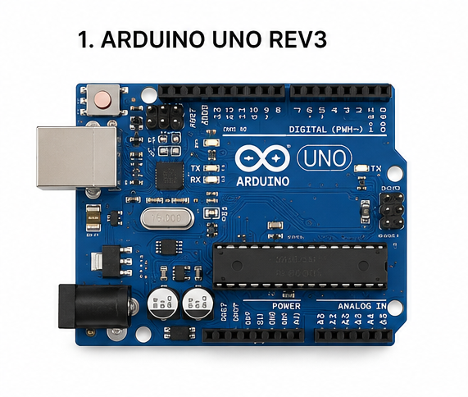  Board Configuration  - 8-bit AVR core (Uno/Mega/Nano) or 32-bit ARM Cortex-M (Due, Zero, MKR series)  - 14 digital I/O pins and 6 analog input pins (Uno)  - USB-B interface for programming and serial communication  - Power input via USB or DC barrel jack (7–12 V)  - UART, SPI, and I²C communication support  Specifications  - Clock Speed: 16 MHz (Uno); up to 84 MHz on ARM-based Arduino Due  - Operating Voltage: 5 V (Uno); 3.3 V on ARM-based boards  - Flash Memory: 32 KB (Uno) up to 512 KB (Due)  - SRAM: 2 KB (Uno) up to 96 KB (Due)  - EEPROM: 1 KB (Uno, AVR-based boards only)  Advantages  - Very easy to learn and program using the Arduino IDE  - Fully open-source hardware and software  - Extremely large community, libraries, and tutorials  - Wide compatibility with sensors, shields, and modules  Challenges  - Limited processing power and memory on AVR-based boards  - No built-in wireless connectivity on the base Uno/Mega boards  - Not suitable for computation-heavy or high-performance applications  Applications  - Robotics and motor control  - Home automation  - IoT sensor-node prototypes  - Educational and academic projects  - Basic sensor and actuator interfacing  2. ESP Family (ESP8266 / ESP32)  The ESP family, developed by Espressif Systems, is a series of low-cost, Wi-Fi-enabled microcontrollers built for wireless and IoT applications. The ESP8266 offers Wi-Fi alone, while the ESP32 adds a dual-core processor and Bluetooth/BLE, making it one of the most widely used SoCs for IoT products.  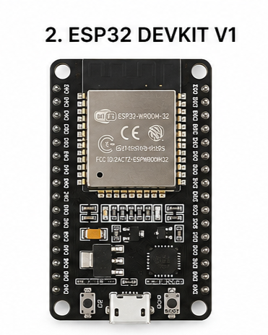  Board Configuration  - ESP8266: single-core 32-bit Tensilica L106 processor with integrated Wi-Fi  - ESP32: dual-core 32-bit Xtensa LX6 processor with Wi-Fi and Bluetooth/BLE  - Multiple GPIO pins with ADC, PWM (LEDC), and touch-sensing (ESP32)  - UART, SPI, I²C, and (on ESP32) I²S and CAN (TWAI) support  - External SPI flash for firmware and file-system storage  Specifications  - Clock Speed: 80 MHz (ESP8266) - up to 240 MHz (ESP32, dual core)  - Operating Voltage: 3.3 V  - Flash Memory: typically 4 MB (module-dependent, 1–16 MB)  - SRAM: ~50 KB usable (ESP8266); 520 KB (ESP32)  Advantages  - Built-in wireless connectivity (Wi-Fi, and BLE/Bluetooth on ESP32)  - High processing speed relative to cost  - Low power consumption with deep-sleep modes  - Very affordable and compact modules  Challenges  - Operates only at 3.3 V logic, requiring level shifting for 5 V sensors  - Active Wi-Fi transmission increases power draw  - Some advanced peripherals require a steeper learning curve  Applications  - Smart home systems  - Wireless sensor networks  - IoT edge devices  - Wearable electronics  - Remote environmental monitoring  3. Raspberry Pi Family  The Raspberry Pi family consists of low-cost, credit-card-sized single-board computers (SBCs) capable of running a full Linux-based operating system. Unlike the microcontroller boards above, the Raspberry Pi executes a multi-tasking OS, making it suitable for advanced embedded computing, edge AI, and multimedia applications.  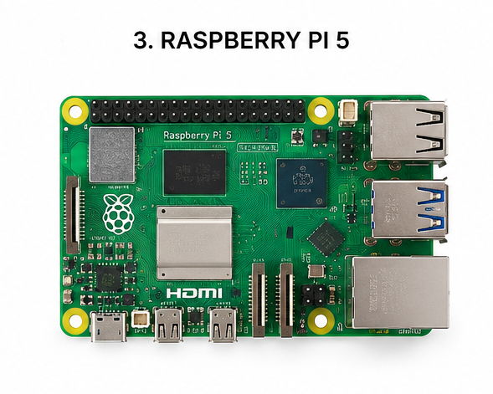  Board Configuration  - Broadcom SoC with quad-core ARM Cortex-A processor (e.g., BCM2711 on Pi 4, BCM2712 on Pi 5)  - 40-pin GPIO header, HDMI output, and multiple USB ports  - Gigabit Ethernet, dual-band Wi-Fi, and Bluetooth 5  - Boots a full Linux-based operating system (Raspberry Pi OS) from microSD/SSD  Specifications  - Processor Speed: 1.5 GHz (Pi 4) to 2.4 GHz (Pi 5), quad-core  - RAM: 1 GB to 8 GB LPDDR4/4X  - Operating Voltage: 5 V (USB-C power delivery)  - Runs Linux-based operating systems (64-bit)  Advantages  - High computing performance compared to microcontroller boards  - Supports multiple programming languages (Python, C/C++, Java)  - Capable of running a full desktop OS and multitasking  - Excellent for AI, computer vision, and networking projects  Challenges  - Higher power consumption than microcontroller boards  - Longer boot time due to full OS  - More expensive and requires storage media (microSD/SSD)  Applications  - Edge AI and image processing  - Robotics controllers  - IoT gateways  - Home-lab servers  - Industrial and home automation hubs  4. BeagleBone Family  BeagleBone is an open-source single-board computer built around Texas Instruments Sitara AM335x processors, designed for embedded Linux applications, industrial automation, and robotics. Its onboard Programmable Real-time Units (PRUs) give it real-time control capability that general-purpose SBCs lack.  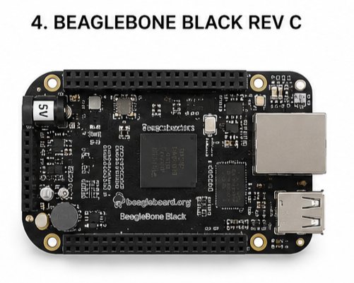  Board Configuration  - ARM Cortex-A8 processor (TI AM3358) with 2 × PRU real-time co-processors  - Two 46-pin GPIO expansion headers (cape connectors)  - Onboard eMMC flash storage plus microSD slot  - Ethernet, USB host/device ports; HDMI on select models  Specifications  - Processor Speed: 1 GHz (Cortex-A8)  - RAM: 512 MB DDR3L  - Operating Voltage: 5 V input, 3.3 V logic  - Runs embedded Linux (Debian-based)  Advantages  - Strong real-time processing via onboard PRUs  - Industrial-grade GPIO and expansion (cape) support  - Fully open-source hardware platform  - Good connectivity for embedded Linux applications  Challenges  - Smaller community than Raspberry Pi  - Fewer ready-made software resources/tutorials  - Comparatively higher learning curve for beginners  Applications  - Industrial automation and control  - Real-time robotics  - Embedded Linux systems  - Sensor data acquisition  - IoT gateways  5. Aries V Series  The Aries V series (ARIES v2.0 / v3.0) is an indigenous Indian development board designed and manufactured by the Centre for Development of Advanced Computing (C-DAC) under the Digital India RISC-V (DIR-V) programme, funded by the Ministry of Electronics and Information Technology (MeitY), Government of India. It is built around the indigenously designed THEJAS32 SoC and is targeted at education, low-power IoT, and sensor-fusion applications.  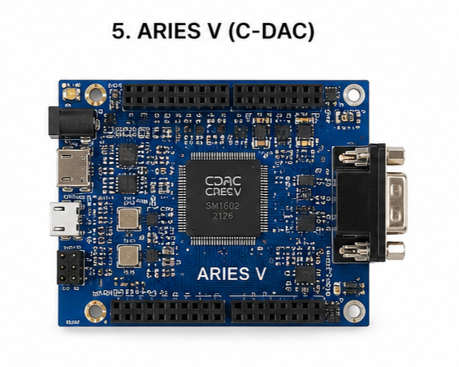  Board Configuration  - THEJAS32 SoC with an indigenous VEGA ET1031, 32-bit RISC-V (RV32IM) processor core  - Arduino-compatible, shield-style header footprint  - 32 GPIO pins with UART, SPI, and I²C peripherals  - Powered via micro-USB or a 7–12 V DC jack; USB port doubles as the primary UART for programming  Specifications  - Clock Speed: 100 MHz  - Operating (I/O) Voltage: 3.3 V  - Internal SRAM: 256 KB; Flash: 2 MB  - Peripherals: 3 UARTs, 4 SPIs, 3 I²C interfaces, 8 PWM channels, 3 timers  Advantages  - India's first indigenously designed RISC-V microcontroller board, supporting the domestic semiconductor ecosystem  - Arduino-IDE compatible, easing the learning curve for students already familiar with Arduino  - Open, GCC-based RISC-V toolchain (VEGA SDK)  - Rich peripheral set (multiple UART/SPI/I²C) for sensor-heavy educational projects  Challenges  - Limited community support and fewer third-party tutorials compared to Arduino/ESP  - Toolchain/board-manager setup is documented mainly for Windows hosts  - Less widely available in the market than Arduino or ESP boards  Applications  - Embedded-systems and RISC-V education  - Low-power IoT sensor nodes  - Sensor fusion and data-logging projects  - Academic laboratory experiments  - Prototype toy and consumer-electronics education kits  6. STM Series (STM32)  The STM32 series, developed by STMicroelectronics, is a family of high-performance 32-bit ARM Cortex-M microcontrollers spanning ultra-low-power (L-series), mainstream (F0/F1/F4), and high-performance (H7) product lines. They are widely used in commercial, industrial, automotive, and medical applications requiring real-time, deterministic control.  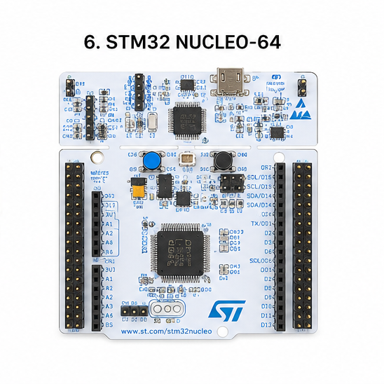  Board Configuration  - ARM Cortex-M0/M0+/M3/M4/M7 processor core depending on series  - Rich set of GPIO pins with ADC, DAC, and PWM (timer) peripherals  - UART, SPI, I²C, CAN, and USB (OTG on many parts) interfaces  - Multiple hardware timers and interrupt controllers for real-time control  Specifications  - Clock Speed: up to 480 MHz (H7 series); mainstream F4 up to 180 MHz  - Operating Voltage: 1.8 V – 3.6 V  - Flash Memory: up to 2 MB (series-dependent)  - RAM: up to roughly 1 MB on high-end H7 parts  Advantages  - High processing performance with deterministic real-time behaviour  - Low power consumption, including microamp-range low-power modes  - Very rich peripheral support (multiple ADC/DAC/timers/communication buses)  - Industrial-grade reliability, widely used in production designs  Challenges  - More complex register-level programming model than Arduino  - Requires a stronger understanding of embedded systems concepts  - Development tools (STM32CubeIDE, HAL) have a steeper learning curve for beginners  Applications  - Industrial automation and motor control  - Automotive electronics  - Medical instrumentation  - Consumer electronics  - Robotics and real-time control systems
Procedure | - Study and understand the purpose of learning about different microcontroller and development-board families used in embedded systems and IoT.  - Identify the different development boards - Arduino, ESP8266/ESP32, Raspberry Pi, BeagleBone, Aries V, and STM32 - either physically in the laboratory or through their official documentation and reference manuals.  - Observe the physical structure of each board, including the microcontroller/processor, USB connector, power-supply section, GPIO pins, communication ports, and onboard indicator LEDs.  - Study the board configuration of each family by identifying the processor type, memory, operating voltage, clock speed, I/O pins, communication interfaces (UART, SPI, I²C), and wireless connectivity, where available.  - Compare the technical specifications of all the boards and note the similarities and differences in processing capability, memory, power requirements, and peripheral support.  - Analyse the advantages and limitations of each board considering ease of programming, processing speed, power consumption, cost, community support, and suitability for different applications.  - Study the application areas of each board family and understand where they are commonly used - robotics, home automation, industrial automation, IoT, healthcare, and educational projects.  - Refer to the official datasheets and documentation of each manufacturer to verify all technical specifications used in the comparison.  - Prepare a comparison table summarising the board configuration, specifications, advantages, challenges, and application areas of each development-board family, and record the overall observations.
Result | Comparison Table of Various Development Board Families  Parameter Arduino Uno ESP Family Raspberry Pi Family BeagleBone Family Aries V Series STM Series  Board Type Microcontroller Dev. Board Microcontroller Dev. Board Single Board Computer (SBC) Single Board Computer (SBC) Microcontroller Dev. Board Microcontroller Dev. Board  Processor ATmega328P Xtensa L106 / LX6 (ESP8266/32) ARM Cortex-A72/A76 ARM Cortex-A8 (AM3358) VEGA ET1031 (THEJAS32) ARM Cortex-M0–M7  Architecture 8-bit AVR 32-bit 64-bit 32-bit 32-bit RISC-V 32-bit  Clock Speed 16 MHz 80–240 MHz 1.5–2.4 GHz ~1 GHz 100 MHz Up to 480 MHz  Operating Voltage 5 V 3.3 V 5 V 5 V (3.3 V logic) 3.3 V 1.8–3.6 V  Flash Memory 32 KB 1–16 MB (external) microSD / SSD boot 4 GB eMMC + microSD 2 MB Up to 2 MB  RAM / SRAM 2 KB 50 KB–520 KB 1–8 GB LPDDR4 512 MB DDR3L 256 KB Up to ~1 MB  EEPROM 1 KB Emulated (flash) - - - -  GPIO Pins 14 digital + 6 analog 17 (ESP8266) / 34 (ESP32) 40-pin header 92 pins (2 × 46) 32 Up to 140+ (package-dep.)  ADC 6 ch, 10-bit 1 ch (8266) / 18 ch 12-bit (32) External ADC (via HAT) 7 ch, 12-bit Available on select pins Multiple 12–16-bit channels  DAC None 2 ch, 8-bit (ESP32 only) External / HDMI audio None onboard None 1–2 ch on many series  PWM 6 pins Software (8266) / 16 ch (32) Software / hardware (limited) 8 ch (via PRU/eCAP) 8 channels Multiple, timer-based  Comm. Interfaces UART, SPI, I²C UART, SPI, I²C (+I²S, CAN on 32) UART, SPI, I²C, Ethernet UART, SPI, I²C, CAN 3× UART, 4× SPI, 3× I²C UART, SPI, I²C, CAN, USB  Wireless Features None (base board) Wi-Fi; + BLE/Bluetooth (ESP32) Wi-Fi 802.11ac, Bluetooth 5 None (add-on capes available) None (IoT variant: Wi-Fi/BLE) None (external modules)  USB Support USB-B (program/serial) Micro-USB (via UART bridge) USB-C power, 2×USB3, 2×USB2 Mini/Micro-USB host+device Micro-USB (power + UART0) USB device/OTG on many parts  Development IDE Arduino IDE Arduino IDE, ESP-IDF, PlatformIO Raspberry Pi OS, VS Code, Thonny Cloud9 IDE, Linux toolchain Arduino IDE, VEGA SDK STM32CubeIDE, Keil, IAR  Programming Languages C/C++ C/C++, MicroPython Python, C/C++, Java, etc. C/C++, Python, JavaScript C/C++ C/C++  Power Consumption Low Low (higher w/ Wi-Fi active) High Moderate Low Very low (µA sleep modes)  Community Support Very large Large Very large Moderate Small / emerging Large (industrial)  Approx. Cost Low ($5–25) Very low ($2–8) Moderate ($35–80) Moderate ($55–70) Low (~$12) Low–moderate ($2–25)  Key Advantage Simplicity, huge ecosystem Built-in wireless, low cost Full OS, high compute power Real-time PRU co-processors Indigenous RISC-V, Arduino-compatible Real-time performance, rich peripherals  Key Challenge Limited memory/compute 3.3 V-only logic Higher power draw, cost Smaller community Limited documentation/availability Steeper learning curve  Typical Application Educational, small embedded IoT, wireless sensor nodes Edge AI, gateways, servers Industrial real-time control RISC-V education, low-power IoT Industrial & automotive control
Conclusion | From this experiment, I understood the working principles, architecture, and configuration of different microcontroller and single-board-computer families - Arduino, ESP8266/ESP32, Raspberry Pi, BeagleBone, Aries V, and STM32 - along with their communication protocols, memory types, and GPIO capabilities. I was able to compare these boards on the basis of processor architecture, clock speed, operating voltage, memory, and wireless connectivity, and identify their respective advantages, challenges, and suitable IoT and embedded-system application areas, which will help me choose the right platform for future embedded and IoT projects.
References | - Arduino, "Arduino Uno Rev3 documentation," Arduino Official Documentation. [Online]. Available: https://docs.arduino.cc/hardware/uno-rev3  - Espressif Systems, "ESP8266EX datasheet" and "ESP32 Series datasheet," Espressif Documentation. [Online]. Available: https://www.espressif.com/en/support/documents/technical-documents  - Raspberry Pi Ltd, "Raspberry Pi 4 Model B" and "Raspberry Pi 5" product specifications, Raspberry Pi Documentation. [Online]. Available: https://www.raspberrypi.com/documentation/  - BeagleBoard.org Foundation, "BeagleBone Black System Reference Manual," BeagleBoard Documentation. [Online]. Available: https://beagleboard.org/black  - Centre for Development of Advanced Computing (C-DAC), "ARIES IoT v2.0 Product Reference Manual" and "Setting Up ARIES Board," VEGA Processor Documentation, Oct. 2022. [Online]. Available: https://cdac-vega.gitlab.io/  - STMicroelectronics, "STM32 32-bit Arm Cortex-M MCUs" product overview and reference manuals, STMicroelectronics STM32 Documentation. [Online]. Available: https://www.st.com/en/microcontrollers-microprocessors/stm32-32-bit-arm-cortex-mcus.html  - ARM Ltd, "Cortex-M and Cortex-A Series Processors," ARM Documentation. [Online]. Available: https://developer.arm.com/documentation  - Texas Instruments, "AM335x Sitara Processors Technical Reference Manual," TI Documentation. [Online]. Available: https://www.ti.com/product/AM3358
Discussion Questions

